Project CM

Function Points

Version 1.2

Revision History

|  |  |  |  |
| --- | --- | --- | --- |
| Date | Version | Description | Author |
| 09/Apr/2014 | 1.0 | Initial function points calculation | Storm Cloud Development |
| 15/Apr/2014 | 1.1 | Updated all calculations | Storm Cloud Development |
| 19/Jun/2014 | 1.2 | Inserted new calculations | Storm Cloud Development |
|  |  |  |  |

Table of Contents

1. Function Point Calculation 4

1.1 Brief Description 4

2. Use Cases 5

2.1 Login 5

2.2 Logout 6

2.3 Manage calendars 7

2.4 Manage Mail Accounts 8

2.5 Manage Rights 9

2.4 Manage Address Book 10

2.5 Manage Appointments 11

2.6 Book Meeting Rooms 12

3. Calculation Diagram 13

# Function Point Calculation

## Brief Description

Function points are a measurement for the complexity of software. They are based on different factors like number of input and output of the user and they’re not based on a special programming language. This document shows the calculations for different use cases.

# Use Cases

## Login

Function point calculation for the use case “login”.



## Logout

Function point calculation for the use case “logout”.



## Manage calendars

Function point calculation for the use case “manage calendars”.



## 2.4 Manage Mail Accounts

Function Point calculation for the Use Case “manage mail accounts”



## 2.5 Manage Rights

Function Point calculation for the Use Case “manage rights”.



## Manage Address Book

Function Point calculation for the Use Case “manage address book”.



## Manage Appointments

Function Point calculation for the Use Case “manage appointments”.



## Book Meeting Rooms

Function Point calculation for the Use Case “book meeting rooms”.

Estimated needed time based on this calculation: 18 hours



# Calculation Diagram

Below you can see the function point calculation diagram. It can be used to estimate the time which has to be spent to implement further use cases, based on the time spent of implemented use cases and their function points.

If you calculate the function points of a new use case, it is possible for you to check the time you probably need to implement this use case. This provides you a tool to enhance your planning of your future work.

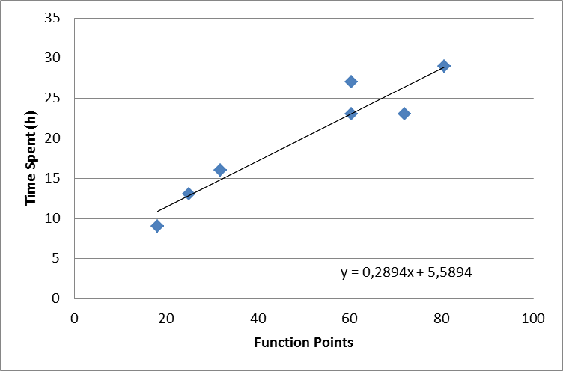

1 Function points in relation to time spent